Generate a hex file for T3 6CTA

1. Make sure application address is 0x8008000

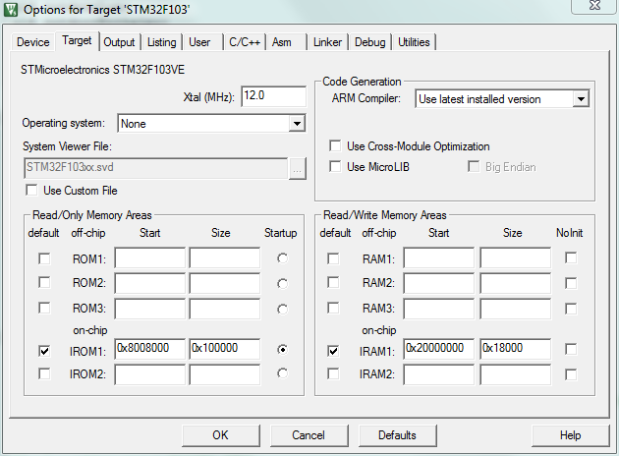

1. Create a Hex file firmware

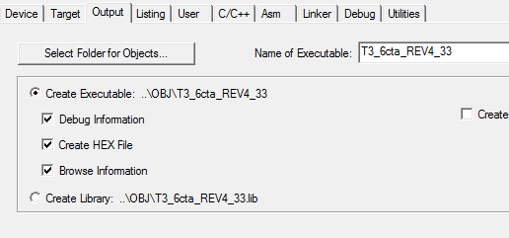

1. Set vector table 0x8008000

cid:image003.png@01D44E7C.B19F10D0